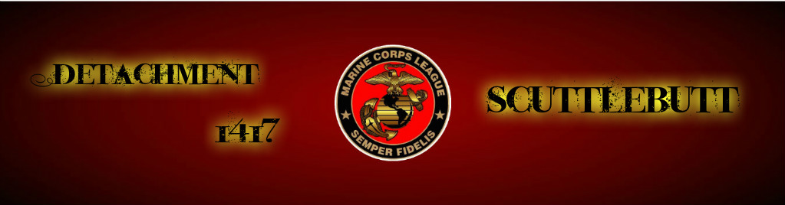
January 2017 Year 2, Edition 1

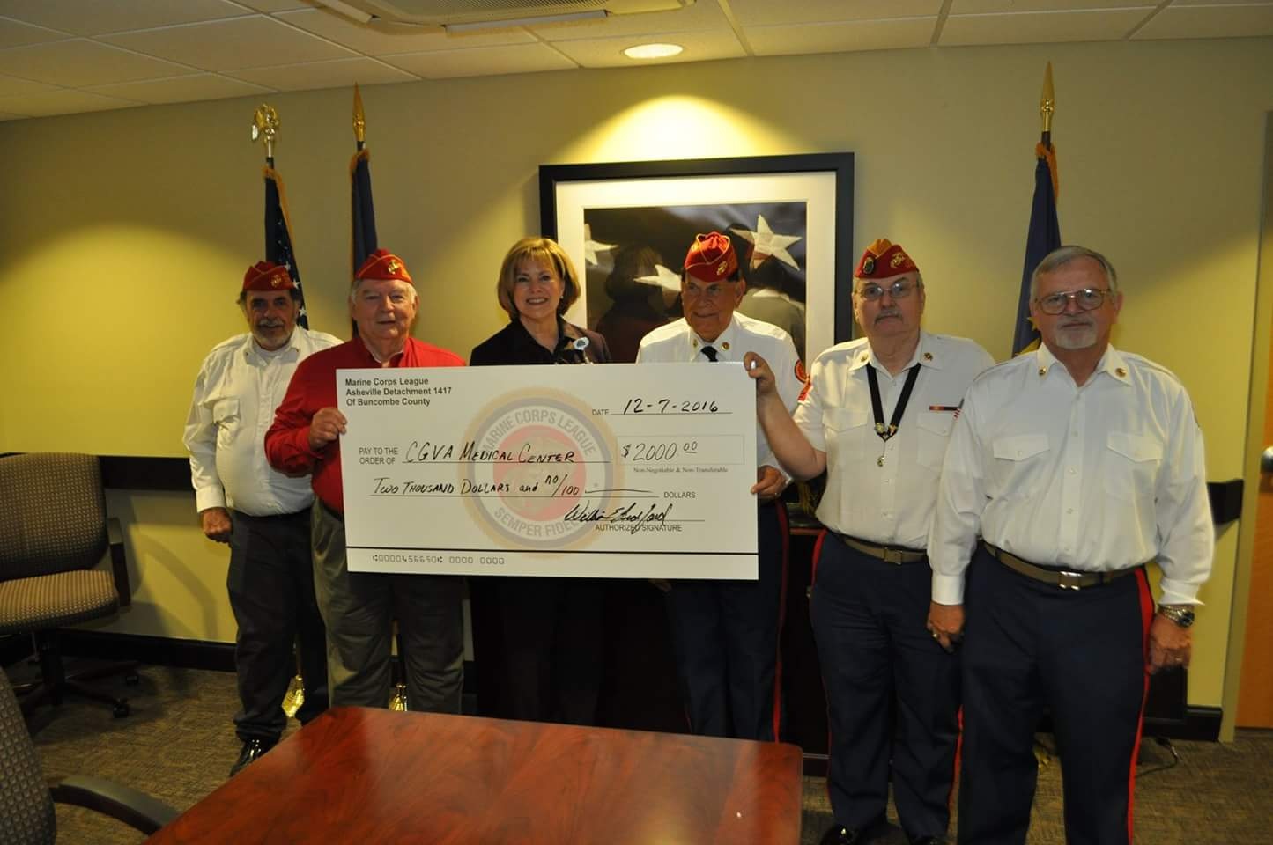
Detachment #1417 donated $2,000 to the VA Hospital to go specifically for PTSD in Mental Health, presented to Cynthia Breyfogal. Members shown: JA Jack Albright, Paymaster Don Alexander, VA Director Cynthia Breyfogal, Chaplain Gene Ray, JPC/DVC Larry Thornton, and Ship Store Director Butch Gudger. (Larry Thornton photo)

Since we last met, there have been many things going on! Look for a special edition coming soon!

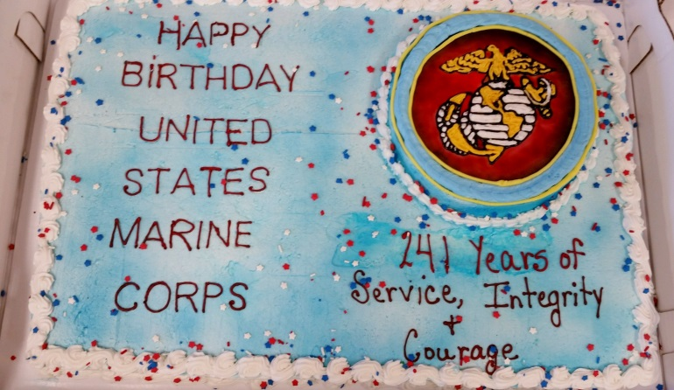

Next Meeting: February 28, 2017

Detachment 1417 Board:

Commandant: Ric Ledford

Sr Vice: Bob Scar

Jr Vice: Don Chatham

Judge Advocate: Jack Albright

Past Commandant: Larry Thornton

Chaplain: Gene Ray

Paymaster: Don Alexander

Sergeant-at-Arms: Bradley Parker

Adjutant/Newsletter/Webmaster Phaedra Laushance

Detachment Email:
mcl.asheville@gmail.com

DATES FROM NC MCL QUARTERLY
*Spring Quarterly:
10-11 March 2017, Asheville, NC

State Convention:
2-3 June, Raleigh, NC

Commandant’s corner

Marines and Associates, I hope this email finds you all well and in good spirits!

It seems like forever ago since we all got together. Holidays and weather kind of put a damper on things for a bit. But, next Tuesday night we will get right back into the swing of things and start moving forward with 2017!

While we have been out of touch a bit, there has still been some movement within the detachment as far as event planning. We are moving forward with our plans for the Spring Quarterly in March and things are really shaping up to show the DoNC officers that we can make things happen in WNC. I will have a sign up sheet at Tuesday nights meeting with specific jobs that will need to be done during the quarterly meeting. We will also need a group of folks to help put together the goody bags that we will give to folks when they register for the meeting on Saturday morning. We will need folks to help restock refreshments, work the registration table, help with lunch, etc...

Also our new activities director, Deanna Parker, has been busy contacting restaurants interested in hosting our monthly dinners as well as getting things in place for our annual picnic in July. Stay tuned for more information on that.

As we move forward this year there are some things that we really need to get nailed down and we are going to need some folks to take the lead on some of these things. There are plenty of opportunities to be part of a committee or even be a committee chairperson.

Scholarships is something we agreed in 2016 we would get established. We need to be gathering information on how to set that up so I will need a volunteer or 2 to help with that.

Fundraising ideas need to be brought forward and streamlined. All this can be coordinated with myself and the activities director once we have agreed on what those fundraising ideas will be. So, if you have a fund raising idea, put together a game plan on how to implement it and a general budget so we know what we are investing to kick it off and an estimated return on that investment (how much money can we potentially make).

I have a friend of mine who is making something for me that I think will be a fantastic raffle item that we can generate funds from. I will provide more details at a later date once I have gotten all my information together from him. It's pretty cool and it's functional.

So, in closing, we have a lot of work to do in 2017 and it's going to take bodies to make it happen. I hope to see you all at our meeting next Tuesday night, 18:30 hours at the American Legion Hall on Haywood Road in West Asheville!
Semper Fi,

Commandant Ledford

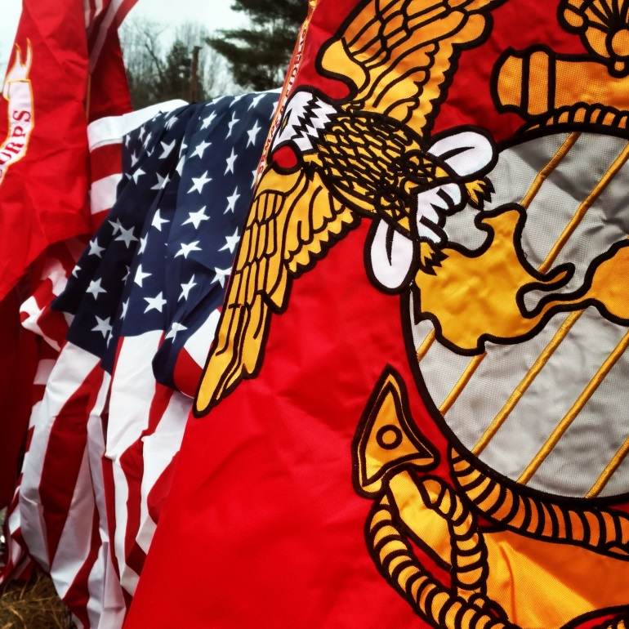

Flying the flags on the back of our float for the Weaverville Christmas Parade on 12/3/16.
(Phaedra Laushance photo)

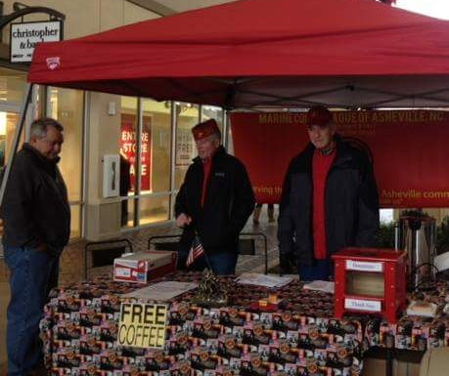

Phil Swartz led the troops in to battle at the Asheville Outlet Mall serving coffee, hot chocolate, water, and an assortment of donuts, brownies and other yummy treats made from our awesome Detachment members and associates! Phil was there each weekend with volunteers from the Detachment for 3 weekends in December, braving the cold and wind, along with the occasional look of gratitude from the weary holiday shoppers! Thanks to Phil and all that donated time and treats!

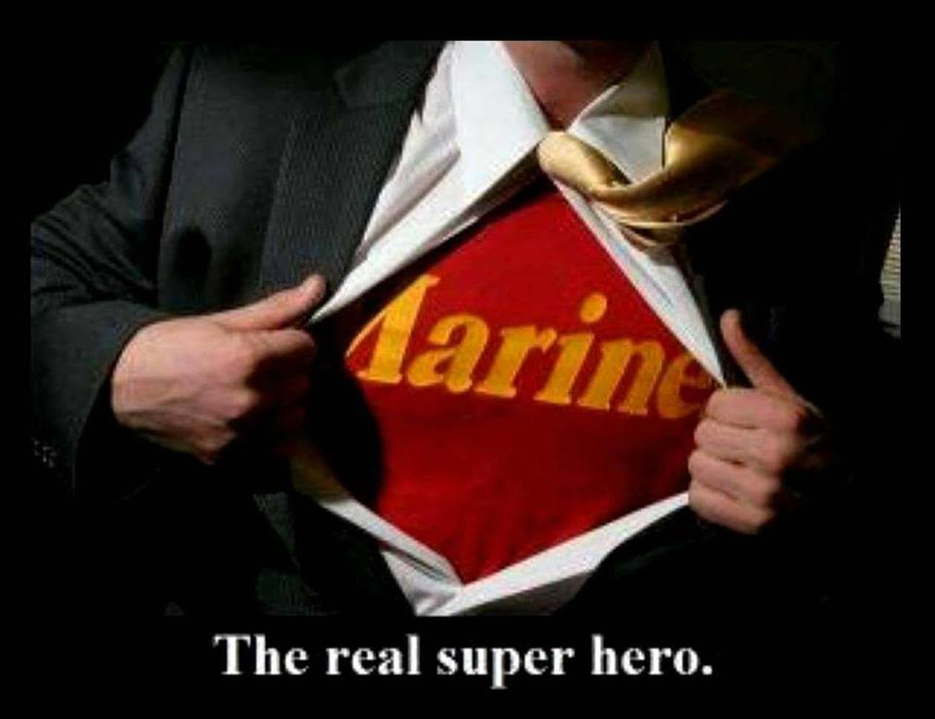

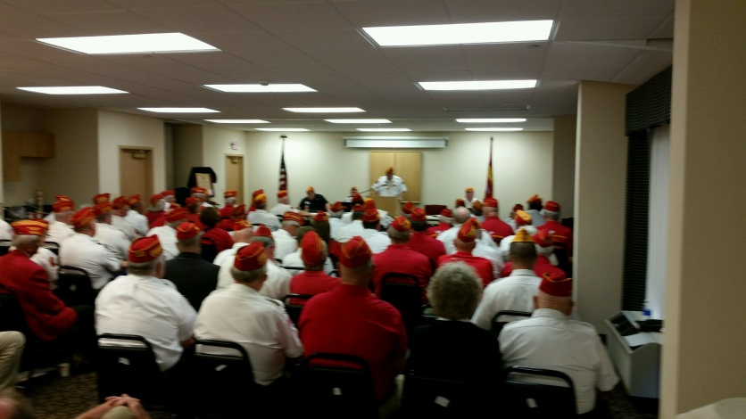
Get ready! The Spring Quarterly happening in Asheville is coming soon! More details at the meeting!

Monthly Dinners:
(All dinners begin at 1800 (6pm) unless otherwise noted.
February 7th: 151 Restaurant, 30 Pisgah Hwy, Candler
March 14th: Texas Roadhouse, 230 Hendersonville Rd, Asheville
April 11th: Pot Luck, Skyland Fire and Rescue, 9 Miller Rd S, Skyland (Rescheduled from January)
May 9th: Tommy's, 247 N. Main St, Weaverville
June 13th: El Chapala, 282 Smokey Park Highway, Asheville
July 8th: Summer Picnic at Lake Julian Park, Pavilion #2. (Time will be announced.
August 8th: (TBD)
September 12th: (TBD)
October 10th: (TBD)
November 10th: Marine Corps Ball
December 6th: O'Charley's—Detachment Christmas Party.

FEB 10, 11, 2017
Friday NOON till 7:00 pm Saturday 8:00 am till 2:00 pm
NORTHEASTERN NC VARO CLAIMS CLINIC
DO YOU NEED TO FILE A CLAIM? HAVE QUESTIONS ABOUT AN APPEAL?
VA RATERS AND DECISIONS MAKERS AVAILABLE FOR YOU TO SPEAK WITH PERSONALLY
SET UP E-BENEFITS ACCOUNTS, DISCUSS PENSION ELIGIBILTY AND WIDOW BENEFITS,
FIND OUT ABOUT EDUCATIONAL BENEFITS, VOCRehab, VA HOME LOAN, AND MORE
HEALTHNET REPRESENTATIVE (CHOICE) TO ANSWER YOUR QUESTIONS, VET CENTER MOBILE MENTAL HEALTH CLINIC, WOMEN VETERANS STAFF AND BENEFITS EXPLANATIONS,LEARN ABOUT MYHealtheVet, VETS.gov and more
HEALTHCARE REPRESENTATIVES WILL BE HELP YOU ENROLL, LOOK AT SPECIALITY APPOINTMENTS AND SO MUCH MORE
ROANOKE RAPIDS THEATRE (PREVIOUSLY RANDY PARTON THEATER) Exit 171 I-95 Behind the Hilton Garden Inn
500 CAROLINA CROSSROADS PARKWAY ROANOKE RAPIDS NC
FOR MORE INFORMATION CALL
JEAN REAVES 252-673-6495 jean.reaves579@gmail.com
≈≈≈≈≈≈≈≈≈≈≈≈≈≈≈≈≈≈≈≈≈≈≈≈≈≈≈
NEW PRESCRIPTION INFO.

Prescription copay rules are changing effective February 27, 2017. The “Medication Copayment” attachment gives a quick summary and will be provided to veteran patients. The current VA medication copay is $8 for a 30 day supply of any medication when the veteran is eligible for a copay.

Copays for the new tiered system:
1) Tier 1 generic medications will be $5 per 30 day supply (See second attachment titled “Tier copay” for list of Tier 1 medications)
2) Tier 2 “non-preferred” generic medications will be $8 per 30 day supply
3) Tier 3 Brand drugs will be $11 per 30 day supply

***Veterans that currently do not have medication copays will NOT be affected. Eligibility standards are still the same, the copays are changing only for those veterans that currently qualify for copays***

The new annual maximum for medication copays for veterans is $700 compared to $960 previously.
Supply items such as diabetic test strips, bandages, etc. will not have copays as current practice (considered “Tier 0”).

Answers to some common questions.
- When will tier copays start? The current date is 2/27/2017.
- Won’t this cost Veterans money? Only for a small percentage. Approximately 94% of veterans will see no increase with 80% getting a savings. In addition copays were scheduled to increase to $11 dollars this year so if nothing was done there would have been an increase on all Veterans. The annual copayment cap will be reduced from $960 to $700 per calendar year which will further insulate Veterans from a cost increase.
- Will service connected veterans be charged a copay? No, these changes apply only to those eligible for a copay as current practice.
- Can a Veteran request a branded product and just pay the higher copay? No, FDA approved generics are still the formulary standard for utilization.
- Will local sites be required make local modifications to complete this process? No. If a drug is matched to NDF the correct copay will be charged.
- Will Birth Control Products, Nicotine Products, and Vitamin D be exempted from copay charges? No. Those exemptions are part of the Affordable Care Act (ACA), however the ACA does not apply to VA. VA works under a different set of copay rules and these rules do not exempt these products.

Thank you AJ Vitt, Associate Chief, Pharmacy Wilmington HCC, for preparing this information for FVAMC.
Thank you,
Mike Thompson
Chief, Pharmacy

Tier 1 CO-PAY MEDICATION LIST 2017
ARTHRITIS AND JOINT PAIN
Aspirin buffered tablet; Aspirin chewable tablet; Aspirin enteric coated tablet; Allopurinol tablet; Diclofenac Sodium EC tablet; Etodolac capsule/ tablet; Ibuprofen tablet; Meloxicam tablet; Methotrexate Sodium tablet; Naproxen tablet
BLOOD THINNERS AND PLATELET INHIBITORS
Clopidogrel Bisulfate tablet; Warfarin Sodium tablet
BONE HEALTH
Alendronate tablet
CHOLESTEROL
Atorvastatin tablet; Gemfibrozil tablet; Lovastatin tablet; Niacin (Slo-Niacin) tablet; Pravastatin tablet; Simvastatin tablet
DEMENTIA
Donepezil tablet
DIABETES
Glipizide tablet; Metformin HCL tablet; Metformin HCL 24hr (SA) tablet
ELECTROLYTE SUPPLEMENT
Potassium SA table;t Potassium SA Dispersible tablet
GASTROINTESTINAL HEALTH
Omeprazole EC capsule; Pantoprazole Sodium EC capsule; Ranitidine tablet
GLAUCOMA AND EYE CARE
Brimonidine 0.2% solution; Dorzolamide 2%/Timolol 0.5% sol; Latanoprost 0.005% solution; Timolol Maleate gel and solution 0.25% and 0.5%
HEART HEALTH AND HIGH BLOOD PRESSURE
Amiodarone tablet; Amlodipine tablet; Aspirin (see Arthritis & Pain); Atenolol tablet; Carvedilol tablet; Chlorthalidone tablet; Digoxin tablet; Enalapril
Maleate tablet; Fosinopril Sodium tablet; Furosemide tablet; Hydrochlorothiazide tablet/capsule; Hydrochlorothiazide/Lisinopril tablet; Hydrochlorothiazide/Triamterene cap/tab; Isosorbide Mononitrate SA tablet; Lisinopril tablet; Losartan tablet; Metoprolol Tartrate tablet; Nifedipine SA capsule; Nitroglycerin sublingual tablet; Nitroglycerin patch; Prazosin HCL capsule; Propranolol HCL tablet; Propranolol HCL SA capsule; Spironolactone tablet; Verapamil HCL tablet; Verapamil HCL SA tablet
MENTAL HEALTH
Bupropion HCL tablet Bupropion HCL SA (12HR-SR) tablet Bupropion HCL SA (24HR-XL) tablet Buspirone HCL tablet Citalopram Hydrobromide tablet Duloxetine HCL EC capsule Escitalopram Oxalate tablet Fluoxetine capsule/tablets Mirtazapine tablet Nortriptyline HCL capsule Olanzapine tablet Paroxetine HCL tablet Quetiapine Fumarate tablet Sertraline HCL tablet Trazodone tablet Venlafaxine HCL tablet Venlafaxine HCL SA tablet/cap
PARKINSON’S DISEASES/RESTLESS LEG SYNDROME
Ropinirole HCL tablet
SEIZURES
Gabapentin capsule Lamotrigine tablet Topiramate tablet
THYROID CONDITIONS
Levothyroxine Sodium tablet
UROLOGIC (BLADDER & PROSTATE) HEALTH
Alfuzosin HCL SA tablet Doxazosin Mesylate tablet Finasteride tablet Oxybutynin Chloride tablet Tamsulosin HCL capsule Terazosin HCL capsule
*********
There are only two kinds of people that understand Marines: Marines and the enemy. Everyone else has a second-hand opinion.
Gen. William Thornson, U.S. Army

Do you know a FMF Corpsman that should have a memorial? The following website has more information!
http://fmfcmf.org/
∞∞∞∞∞∞∞∞∞∞∞∞
do you know these individuals?
Robert Putnam - Asheville
Ian Zepp - Arden
Robert Parker - Mills River
Frank Fazio - Hendersonville

These are marines at large (MALs), and we are looking to bringing them in to the mcl! Let Don chatham, Ric Ledford, or Larry thornton know any information to help us raise our recruitment numbers! Thanks!
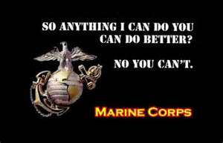
A message from the National Commandant Richard Gore

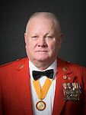

January 13, 2017
Marines,
I would like to start off by wishing everyone a "Happy New Year" and wishing all a lot of success and happiness in 2017. Let's make this the year that we bring the Marine Corps League into the 21st century and keep it there. With continued technical upgrading and BEST operating practices for each and every Detachment, Department, and League Member on our rolls. All Detachments should be looking at our Members at Large and encouraging them to join their Detachment in the areas where they live so they can help contribute to the Detachments success.

We no longer reside at our old location in Fairfax, Va. As of 10/01/2016 we have moved to; 3619 Jefferson Davis Highway, Ste. 115, Stafford Va. 22554 Phone #703-207-9588. All paper work of any type should be sent to this address from this time on. This location is approx. 3 miles south of the Main Gate at Quantico, and the entrance to the Museum of the Corps. Please stop in and visit and see the new location and meet the HQ staff. It is your HQ and you are always welcome. (You will be very surprised)

If you receive "Leatherneck" magazine from the MCA you may have seen the article published about the League in the last issue. We have worked with the staff of the MCA and will be publishing an article or ad in our magazine about them in a future edition. This is an agreed upon event between our two organizations to start and continue working as a team to facilitate joint memberships and calibrations on some of our endeavors. We as Marines should be working as a T.E.A.M. and we are now working in that direction together. We are also trying to work out a relationship with the "Museum", so when people visit they will know we are just down the street, come and visit or join. I still believe a great many Marines have never heard of our existence.

Remember to make your reservations for the Midwinter Conference to be held March 2nd to March 4th at the Fredericksburg Hospitality House, Fredericksburg, VA, 22401. Once again we have many classes to offer on the new paperwork changes and how to use the changes to make your work easier to when submitting it to National.

Also be sure and purchase your Tour Raffle tickets to possibly win yourself a chance of a lifetime trip with "Military Historical Tours", which will be drawn at the banquet on Saturday night. The chances are $5.00 each or 5 for $20.00. The tickets are in the Fall 2016 edition of the "Semper Fi" Magazine. You can't win unless you take a chance!!!
Pretty soon you will be receiving your latest edition of "Semper Fi", published by our new publisher. It would be refreshing for you to respond to HQ, myself or the Exec. Dir. with your comments. Please let us know what you would like to see and any other comments you may have. If anyone would like to advertise in the magazine be sure to call the publisher and they will give you the new rate and get you on board.
If you have any questions pertaining to the functioning of the League be sure to utilize your chain of command/responsibility. They can give you the answers you need. HQ staff is extremely busy working for all the membership. Operational questions should be directed to the proper personnel from your chain of command/responsibility. If you have exhausted your resources and still have not found a resolution/answer send a short email to me and I will get you a response if necessary.
See you all soon.
"Semper Fi"
Richard D. Gore, Sr.
National Commandant
Marine Corps League

“A Marine is a Marine. I set that policy two weeks ago - there's no such thing as a former Marine. You're a Marine, just in a different uniform and you're in a different phase of your life. But you'll always be a Marine because you went to Parris Island, San Diego or the hills of Quantico. There's no such thing as a former Marine.”
General James F. Amos, 35th Commandant of the Marine Corps
*******************

Do you know someone would enjoy being involved with the Detachment happenings? Are they a Marine or FMF Corpsman? If so, let Don Chatham know, and he will get some information sent! Or…direct them to our website! And don’t forget to grab some cards from Phil Swartz to hand out to potential members!

Our website address is:
www.ashevillemcl.org

≈≈≈≈≈≈≈≈≈≈
Are you on Facebook? Join us on our Facebook page at https://www.facebook.com/marinecorpsleagueasheville/

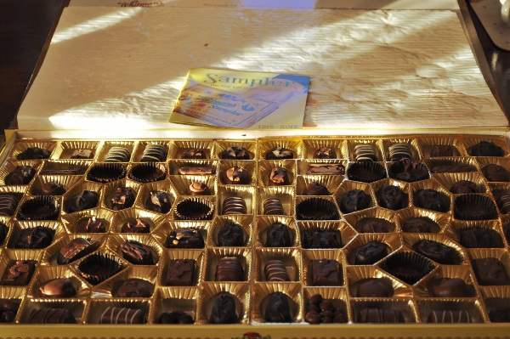
Whitman’s Chocolate and the Citrus Sampler are the preferred #1417 Christmas Party gifts! (I’m pretty sure that will go down in the annals of #1417 history!)
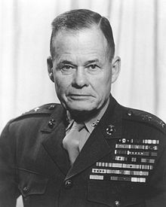
"Good night, Chesty, wherever you are!"

